Information Bulletin

Dear White Water Enthusiasts and Sports Friends,
On behalf of Kerala (India) Tourism, Indian Kayaking & Canoeing Association (IKCA) a registered body of International Canoe Federation and Asian Canoe Confederation in collaboration with Goodwave Adventures (Madras Fun Tools) in coordination with DTPC, Kozhikode is pleased to invite you to take part in the 7th version of Malabar River Festival – MRF 2019 Open International Wildwater Kayak & Slalom Competition. We will hold this competition in Tusharagiri, Kozhikode, Kerala (India) on 26-28 July 2019.

Last year’s edition was touted to be one of Asia’s largest extreme kayaking events. The rivers that featured as part of this festival were Kuttiyadi, Chalipuzha, and Iruvanjhipuza. With over 150 participants competing for the top spot, including Olympians and World Champions such as Mike Dawson, Dane Jackson, Nouria Newman and the likes, MRF 2018 proved to beat its own expectations!

We are extremely excited to host another version of Malabar River Festival this year. Having proven high level experience from organizing of this festival from past 6 years, and accompanied with a high degree of media exposure, the team of IKCA & MRF is ready to prepare and conduct the 7th version of Malabar River Festival this year.

The IKCA & MRF team welcome all athletes for the training and the competition and we hope that MRF 2019 will bring to you not just a lot of top sport performances but also opportunities for you to experience the adrenaline, the rising local talent and the welcoming culture of Kerala (India).

We are looking forward to see you!

We now present a summary of the most important information. More information regarding this event can be found on the web site at www.malabarfest.com.
Sincerely,
Prashant Kushwaha – Secretary General IKCA
Manik Taneja, Co-founder – Malabar River Festival
Jocopo Nodera, Co-founder – Malabar River Festival

Contents

About the Competition 3
Getting there 4
Event Formats 5
River Locations 6
Prize money 6

About the Competition

The Malabar River Festival is South India’s only extreme slalom & kayak competition organized on behalf of Kerala Tourism by DTPC Kozhikode and Goodwave Adventures (Madras Fun Tools). This year it’s a pleasure to announce that we have collaborated with Indian Kayaking & Canoeing Association (IKCA) which is a registered body with International Canoe Federation and a recognized body to organize the Kayaking, Wildwater, Rafting, Slalom events in India.

After a highly successful event last year, the Malabar River festival returns this year on July 26-28, 2019. The challenging waters of God’s Own Country beckon only the best!

This year’s competition will feature events for intermediate wild water kayakers and professionals with a special category of prizes for the best paddlers of the Indian subcontinent. There is something in it for everyone, so see you on the river!

Getting there

Caressed in the folds of the Western Ghats is the picturesque Thusharagiri. You have various options to reach this wild water haven.

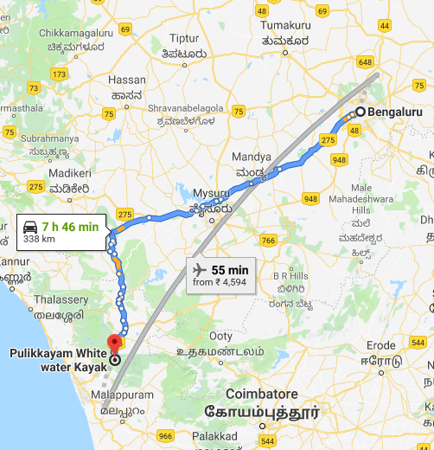
AIR

Closest Airport:
Calicut/Kozhikode - 50 kms
Cochin/Kochi - 150 kms
Bangalore - 310 kms

RAIL

Closest Train Station: Calicut/Kozhikode (CLT)

ROAD

Closest Drop off point (Bus): Adivaram - 6kms
Regular overnight buses ply from Bangalore to Calicut
Route map via Bangalore:
Bangalore -> Mysore -> Sultan Bathery -> Adivaram -> Kodenchery

Event Formats

Here are the competition categories at the Malabar River Festival.
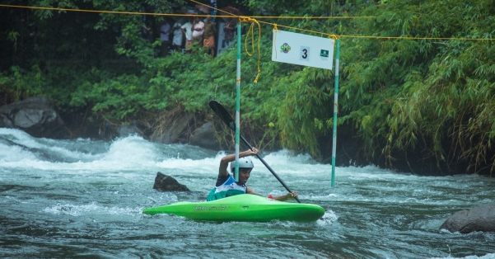

SLALOM

Individual kayakers have to pass through hanging gates along a specified downriver route. Points are scored and lost for effectively passing through the gates.

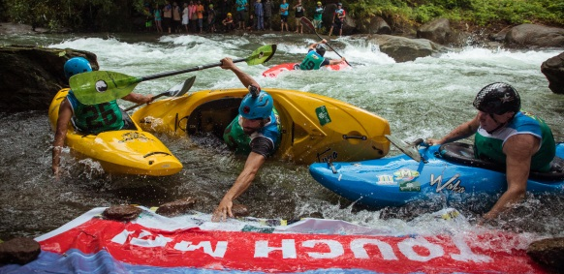
BOATER CROSS

Boater cross is a race where four kayakers try to be fastest to reach the finish line downriver. Obstacles may be added to the course to make it tougher.

DOWNRIVER TIME TRIAL

Individual kayakers sprint down the rapid to record the fastest time they can manage among all the competitors.

River Locations

- Iruvanjipuzha (Tributary of the Chaliyar River), Thusharagiri, Kerala (India)
- Chalipuzha (Tributary of the Chaliyar River), Tusharagiri, Kerala (India)

Prize money

- Total prize money for Professional category: USD 15,000
- Gear and Equipment prizes for Amateur category worth USD 5000

Registrations: www.malabarfest.com
Information also available on
www.ikca.in
www.canoeicf.com
www.asia-canoe.com

